**Name: Nafinur Leo**

**Id: 20-42195-1**

**Course Name: Data Communication**

**Section: D**

**Lab Report Number: 04**

**Semester: 2021-2022 Fall**

**Submission Date: 18-10-2021**

**Lab Performance Task**

ID = AB-CDEFG-H

Here, my id is: 20-42195-1

A = 2, B = 0, C = 4, D = 2, E = 1, F = 9, G = 5, H = 1

x = A1 sin(2π((C+D+H)*100)t ) + A2 cos(2π((D+E+H)*100)t) + s*randn(size(t))

a)Value of the amplitudes:

A1 = (A+B+H) = 2 + 0 + 1 = 3

A2 = (B+C+H) = 0 + 4 + 1 = 5

s = (C+D+H)/30 = (4 + 2 + 1)/30 = 7/30

b)SNR value of the composite signal:

Code:

clc

close all;

A = 2;

B = 0;

C = 4;

D = 2;

E = 1;

F = 9;

G = 5;

H = 1;

A1 = (A+B+H);

A2 = (B+C+H);

s = (C+D+H)/30;

fs = 2000;

t = 0:1/fs:0.1;

x = A1*sin(2*pi*((C+D+H)*100)*t ) + A2*cos(2*pi*((D+E+H)*100)*t) + s*randn(size(t));

nt = s*randn(size(x));

SNR = snr(x, nt)

defSNR = 10^(SNR/10)

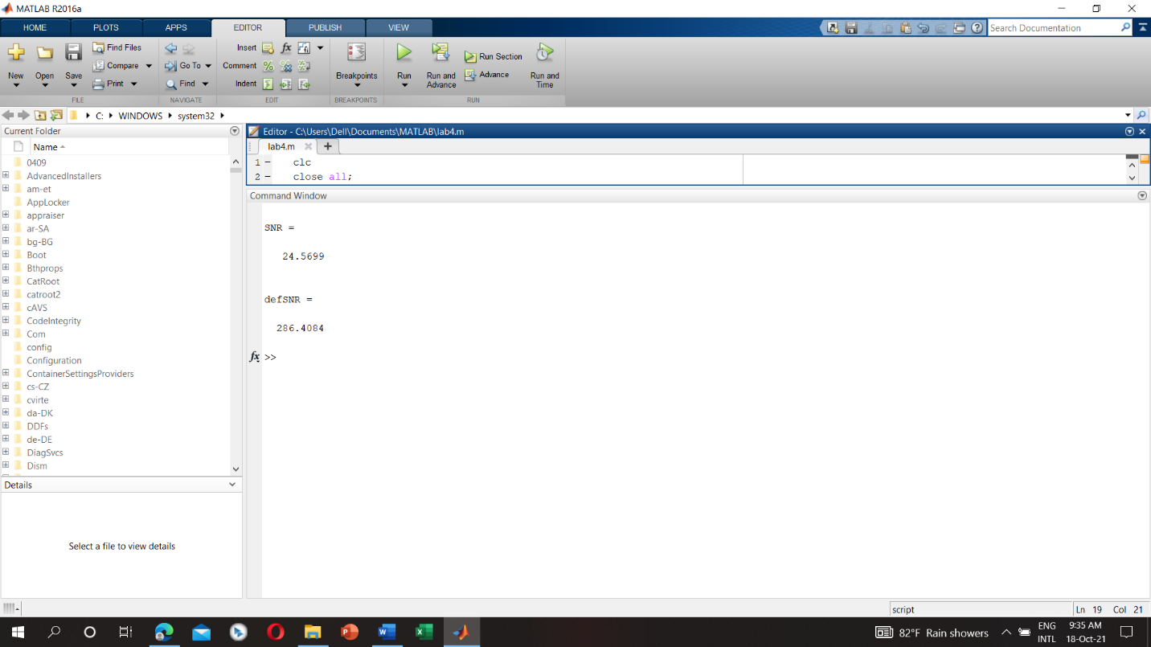

c) Bandwidth of the signal and maximum capacity of the channel:

Code:

clc

close all;

A = 2;

B = 0;

C = 4;

D = 2;

E = 1;

F = 9;

G = 5;

H = 1;

A1 = (A+B+H);

A2 = (B+C+H);

s = (C+D+H)/30;

fs = 2000;

t = 0:1/fs:0.1;

x = A1*sin(2*pi*((C+D+H)*100)*t ) + A2*cos(2*pi*((D+E+H)*100)*t) + s*randn(size(t));

nt = s*randn(size(x));

SNR = snr(x, nt);

defSNR = 10^(SNR/10);

Bandwidth = obw(x,fs)

Capacity = Bandwidth*log2(1+defSNR)

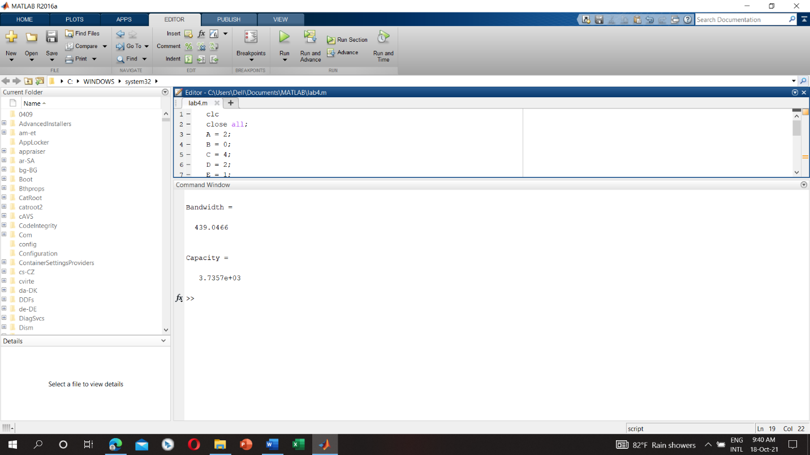

d) Signal level:

Code:

clc

close all;

A = 2;

B = 0;

C = 4;

D = 2;

E = 1;

F = 9;

G = 5;

H = 1;

A1 = (A+B+H);

A2 = (B+C+H);

s = (C+D+H)/30;

fs = 2000;

t = 0:1/fs:0.1;

x = A1*sin(2*pi*((C+D+H)*100)*t ) + A2*cos(2*pi*((D+E+H)*100)*t) + s*randn(size(t));

nt = s*randn(size(x));

SNR = snr(x, nt);

defSNR = 10^(SNR/10);

Bandwidth = obw(x,fs);

Capacity = Bandwidth*log2(1+defSNR);

Signal_level = (2^(Capacity/(2*Bandwidth)))

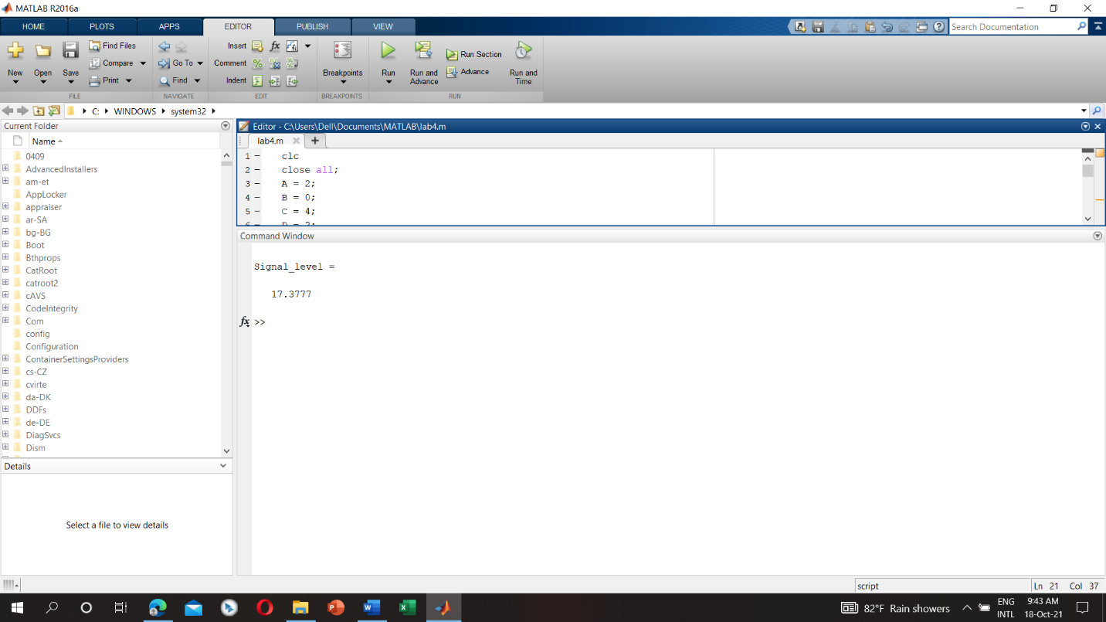

**Discussion:**

There is some of the bugs concluded with the definite organizational complementation with the functions of the MATLAB. The regression of the functions originated from the libraries inclines the comprehensive objective of this complementation. I face some problems while creating the plot and also face problems while calculation using my student id number. MATLAB takes some time while I try to run because my laptop configuration is low.